

**Dnext Platform Catalog 2025**

Empowering decisions with data-driven insights

August 2025 Edition

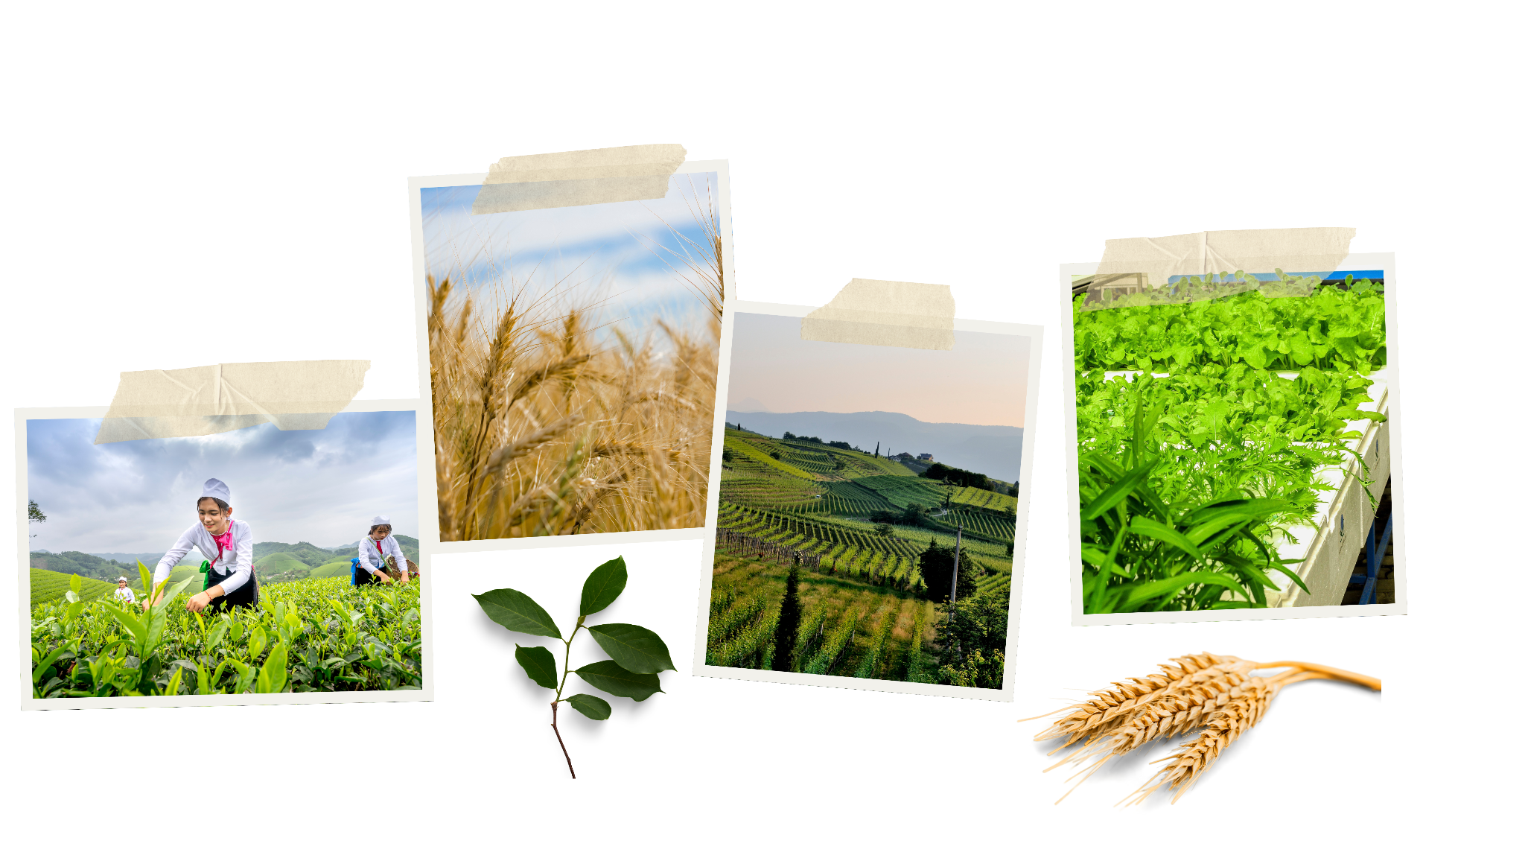

**Introduction :**

This catalog brings together a collection of interactive dashboards covering agriculture, weather, production, trade flows, and Economics. Each dashboard is designed to provide clear, actionable insights to support better decision-making across industries.

**Table of Contents :**

Dashboard Thematic Areas

**1. Compound Feed Production 4**

**2. COT Activity 5**

**3. Crop 6**

**4. Customs 8**

**5. Economics 11**

**6. Grain Processing for Compound Feed 15**

**7. Lineups 16**

**8. Meat Production 17**

**9. Sugar Production 18**

**10. Supply and Demand 19**

**11. Weather 22**

**12. Freight Matrix 27**

**13. Geographic Scope of DNEXT Analysis 28**

# **Compound Feed Production**

* Purpose :

To monitor and analyze the annual and monthly production quantities of compound feed in Europe (France / United Kingdom), segmented by animal and product type, over selected crop years. The dashboard enables users to track production trends, compare year-over-year changes, and analyze seasonal variations.

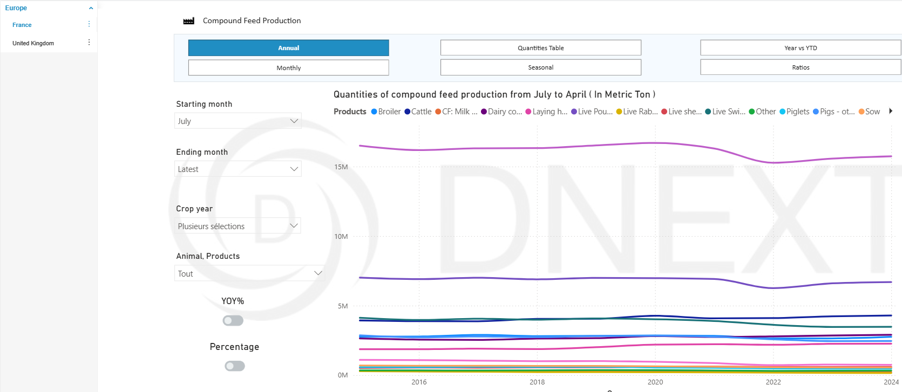

* Main Metrics / KPIs :
* Quantities of compound feed production (in metric tons)
* Filters / Parameters :
* Geography: Country selection (France, United Kingdom)
* Period: Starting month (e.g., July), Ending month (latest or selected)
* Crop Year: Multiple selections possible
* Animal / Product type: Broiler, Cattle, Milk Replacer, Dairy cows, Laying hens, Live Poultry, Live Rabbits, Live sheep and goats, Live swine, Piglets, Pigs - others, Sow, Turkey, Other…
* View Mode: Annual or Monthly
* Analysis Type: Quantities table, Seasonal, Year vs YTD, Ratios

**Quantities Table View:** Displays compound feed production volumes by product type (e.g., cattle, dairy cows, live swine, poultry, etc.) for the selected period. It includes comparisons vs. last year and the 5-year average, with percentage change indicators. Values are expressed in metric tons, thousand metric tons, or million metric tons depending on the unit selected.

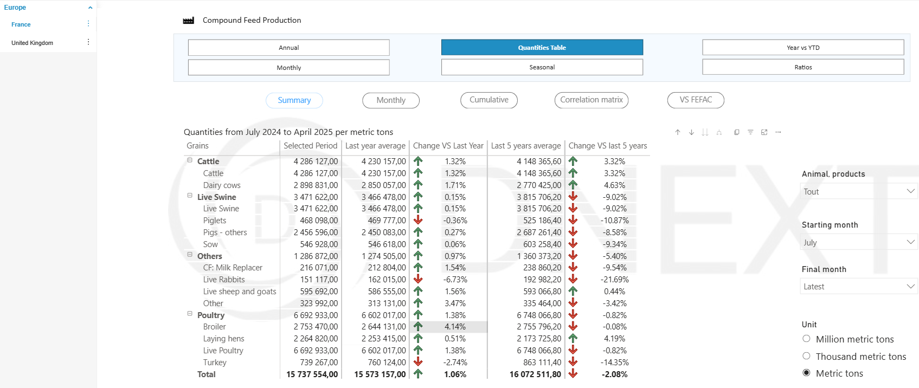

# **COT Activity**

* Purpose :

To track and analyze the positioning of managed money in wheat futures markets over time, providing insights into market sentiment, speculative activity, and overall market participation.

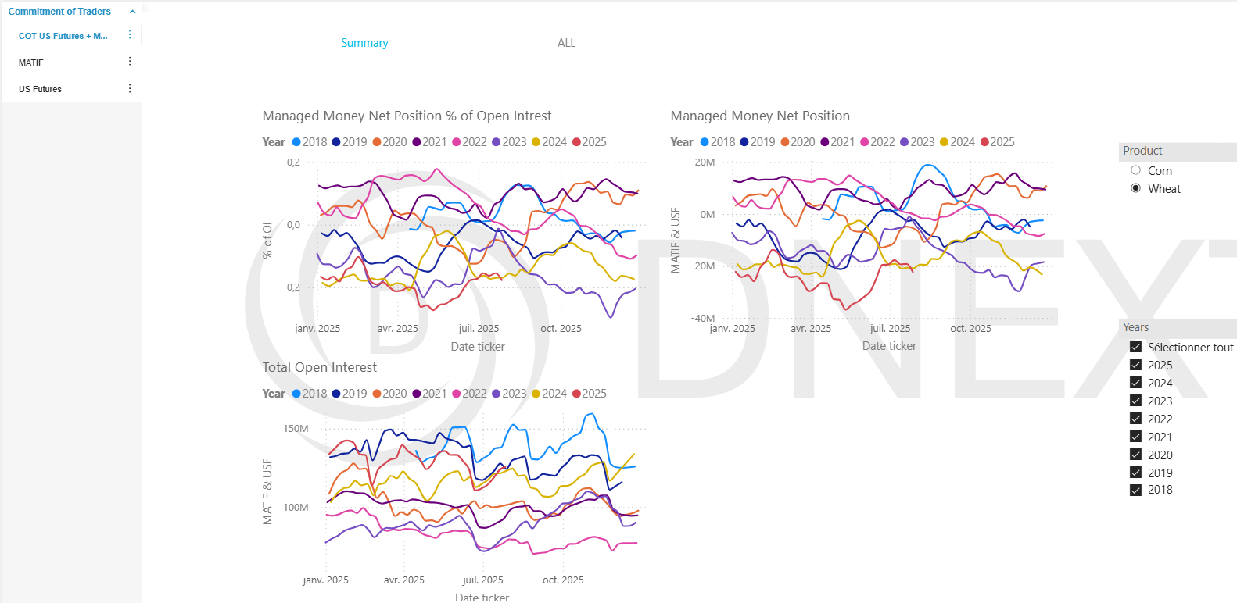

* Main Metrics / KPIs :
* Managed Money Net Position % of Open Interest
* Managed Money Net Position
* Total Open Interest
* Filters / Parameters :
* Product Selection: Wheat or Corn
* Year Selection: Multiple years available (2018–2025) for historical comparison
* View Mode: Summary or All (detailed view)

# **Crop**

**Dashboard 1 : Crop Condition**

* Purpose :

This dashboard provides insights into crop performance in different countries, such as Argentina, Brazil, Canada, Ukraine, and USA, across multiple years and crop types. It tracks key metrics to support decision-making for farmers, agronomists, commodity traders, and agricultural policymakers.

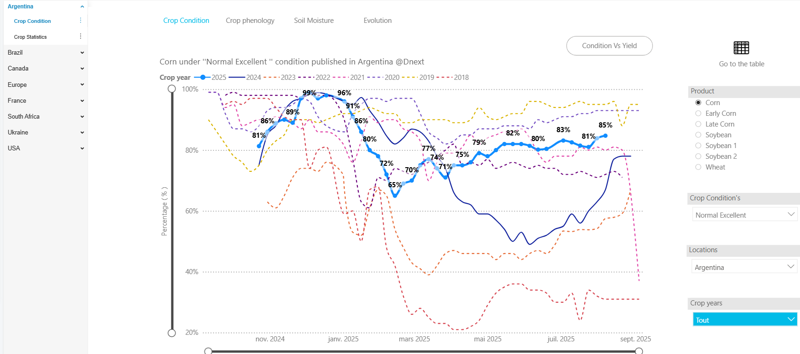

* Main Metrics / KPIs :
* Crop Condition Percentage
* Filters / Parameters:
* Product Selection: Soybean or Wheat or Corn
* Crop Condition Selection : Bad / bad Regular / Normal / Good / Excellent / Good Excellent
* Crop Years Selection
* Location Selection

**Dashboard 2 : Crop phenology**

* Purpose :

This dashboard provides a comprehensive view of crop phenology progression by month during a specific year.

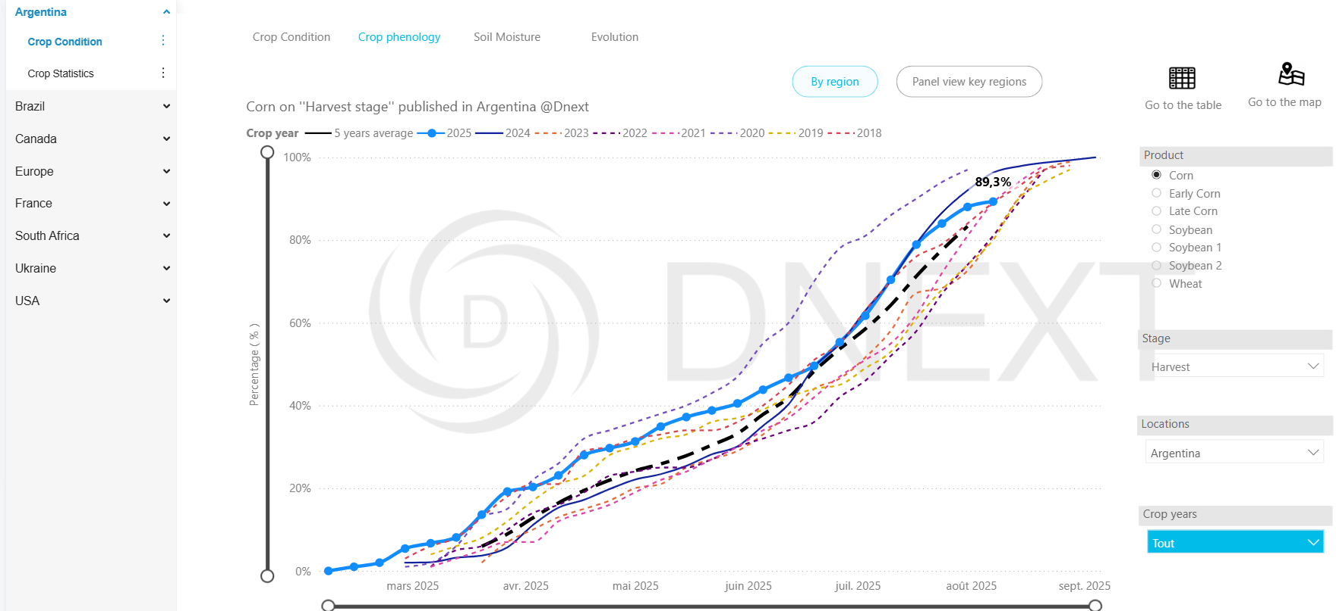

* Main Metrics / KPIs :
* Percentage of [Crop] in the [Growth Stage] stage by month during [Year]
* Filters / Parameters :
* Product Selection: Soybean or Wheat or Corn
* Growth Stage : Planting / Vegetative / Tasseling / Silking / Doughing / Mature / Harvest
* Location Selection
* Crop Year Selection

**Dashboard 3 : Soil Moisture Conditions**

* Purpose :

This dashboard displays monthly crop soil moisture variations during a specific year.

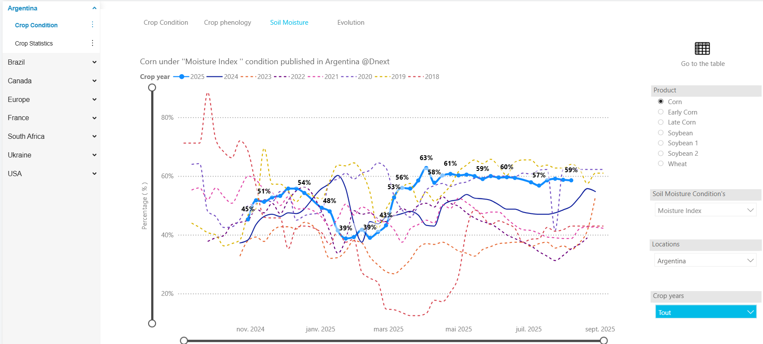



* Main Metrics / KPIs :
* Monthly Soil Moisture Percentage for [Crop] During [Year].
* Filters / Parameters:
* Product Selection: Soybean or Wheat or Corn
* Soil Moisture conditions : Dry / Adequate / Optimum / Adeq Opt / Excessive
* Location Selection
* Crop Year Selection

**Dashboard 4 : Evolution**

* Purpose :

This dashboard provides an interactive analytical platform for monitoring and comparing major variables for production data over multiple years.

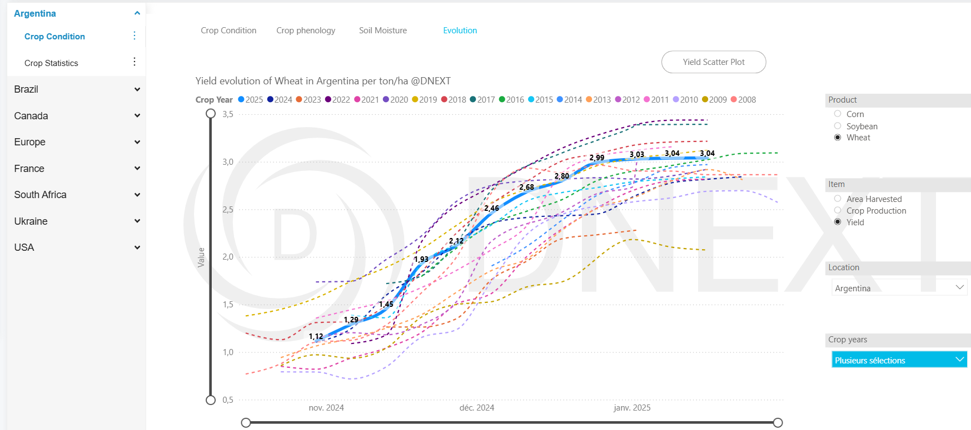

* Main Metrics / KPIs :
* Crop production to track total output of wheat (or selected crop) annually.
* Filters / Parameters:
* Product Selection: Soybean or Wheat or Corn
* Item : Area Harvested / Crop Production / Yield
* Location Selection
* Crop Years Selection

# **Customs**

**Calendar :**

* Purpose :

It helps track when different regions or countries are scheduled to release or update datasets. We use it for planning analysis and decision-making because we know in advance when new information will become available.

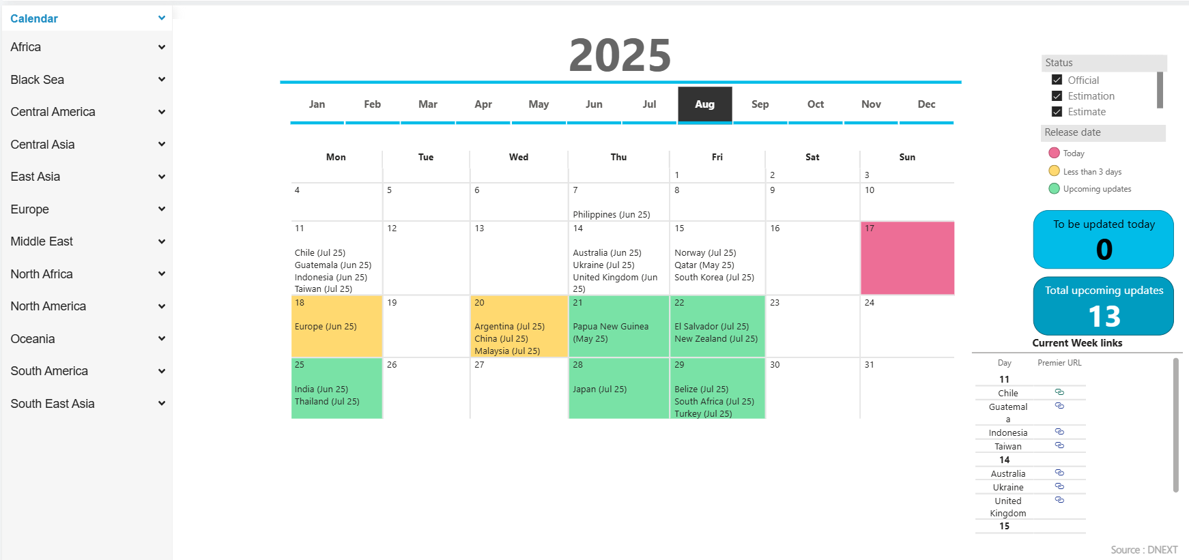

* What it shows :
* Dates : Each day marks when a country/region is expected to release data.
* Countries/Regions : Listed under each date.
* Status Legend (right side): Pink = Release today / Yellow = Release in less than 3 days / Green = Upcoming updates (future scheduled releases).
* Counters :
  + To be updated today : Shows how many updates are scheduled for the current date.
  + Total upcoming updates : Counts all future releases.
* Current Week Links : Quick links to the latest week’s releases for easy access to details.
* Regional Filters (left panel) : You can filter by Africa, Europe, North America, etc., to see relevant updates.

**Dashboards :**

**Example 1 : East Asia / Japan dashboard :**

* Purpose :

To track and compare Japan’s imports/exports across various product categories over time.

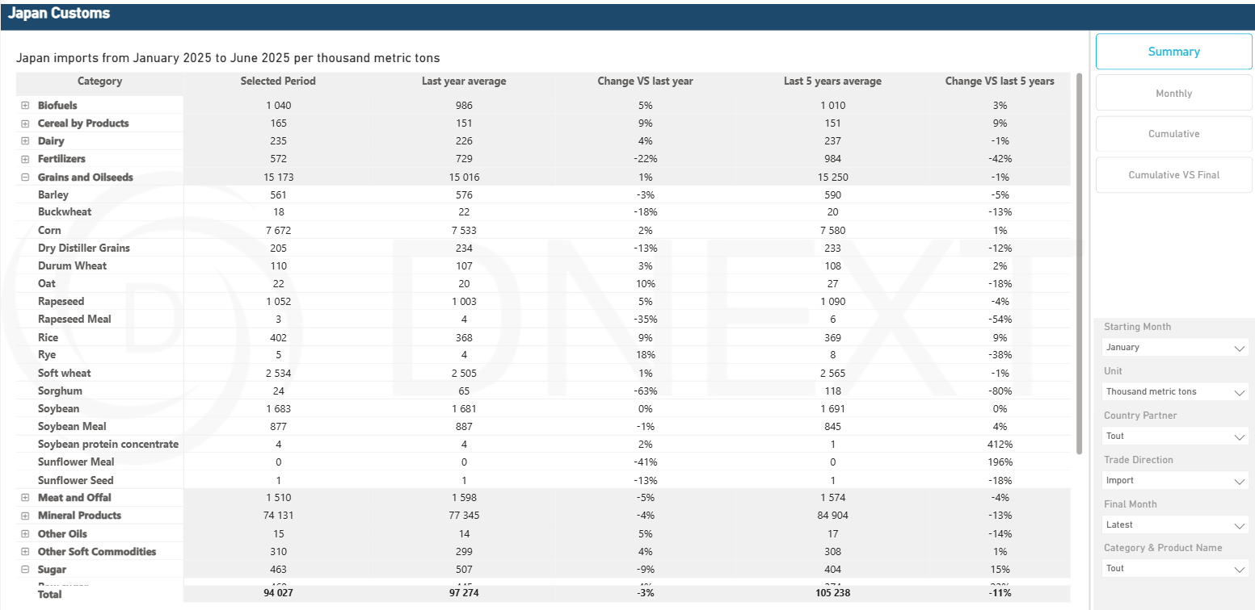

* Main Metrics / KPIs :
* Last Year Average
* Change vs Last Year
* Last 5 Years Average
* Change vs Last 5 Years
* Total Imports/Exports
* Filters / Parameters:
* Summary / Monthly / Cumulative / Cumulative vs Final : Switch between different views of the data.
* Starting Month : Select the first month for the reporting period (e.g., January, February).
* Unit : Measurement unit (here it’s thousand metric tons).
* Country Partner
* Trade Direction : Import or Export.
* Final Month : Select the last month for the reporting period (e.g., June, July, Latest).
* Category and Product Name : Filter by product group (e.g., Dairy, Fertilizers, Grains and Oilseeds) or specific commodities (e.g., Corn, Rice, Soybean).
* Regional Selector (Sidebar).

**Example 2 : South America / Brazil dashboard :**

* Purpose :

To track and compare Brazil’s imports (in thousand metric tons) across various product categories over time.

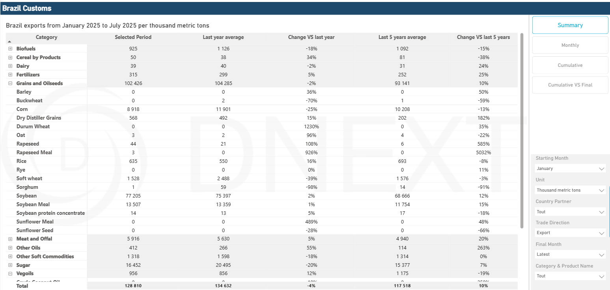

# **Economics**

* Purpose :

Present different types of prices including CNF and cash prices for various products across multiple countries.

**Example 1 : Corn CNF prices**

* **FOB Matrix :**

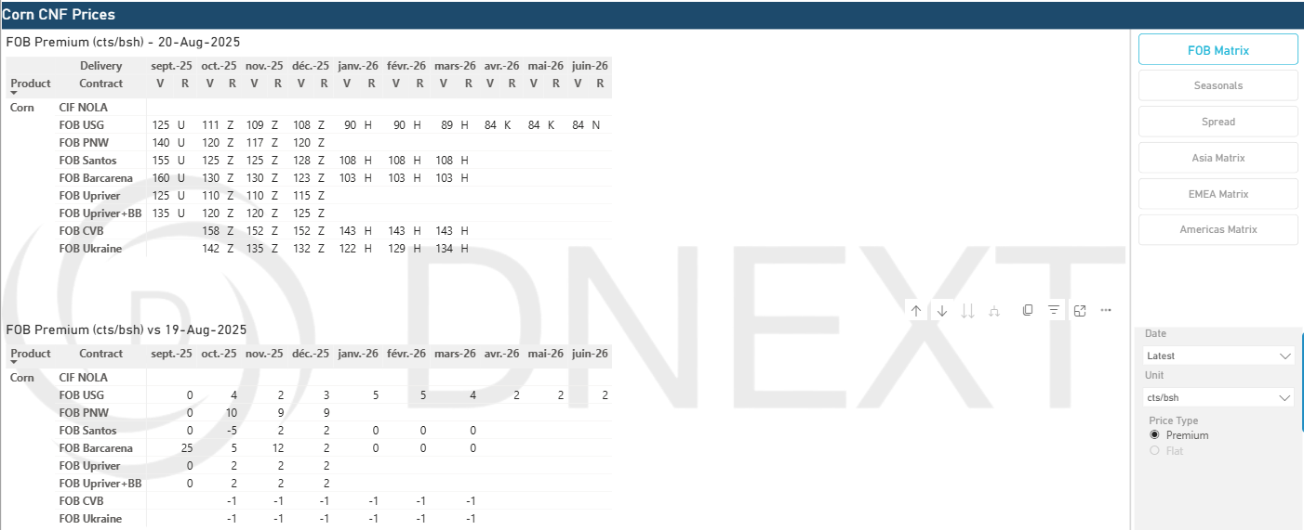

* **Seasonals (Santos) :**

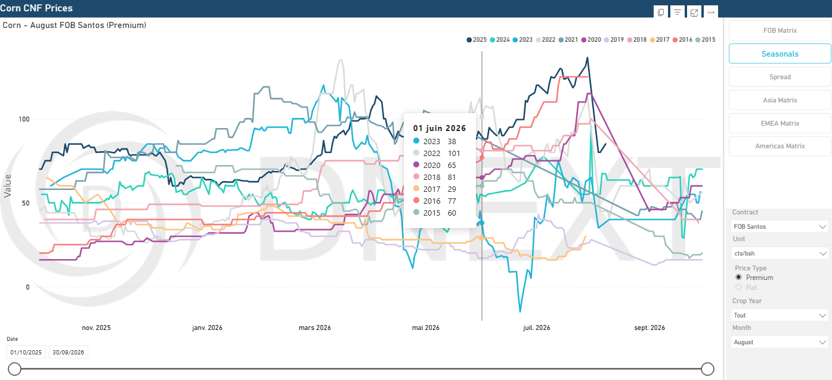

* **CNF Premium Spread (Between Santos and USG) :**

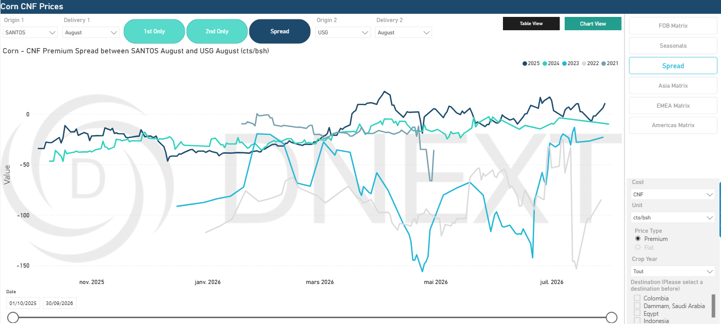

* **America’s Matrix :**

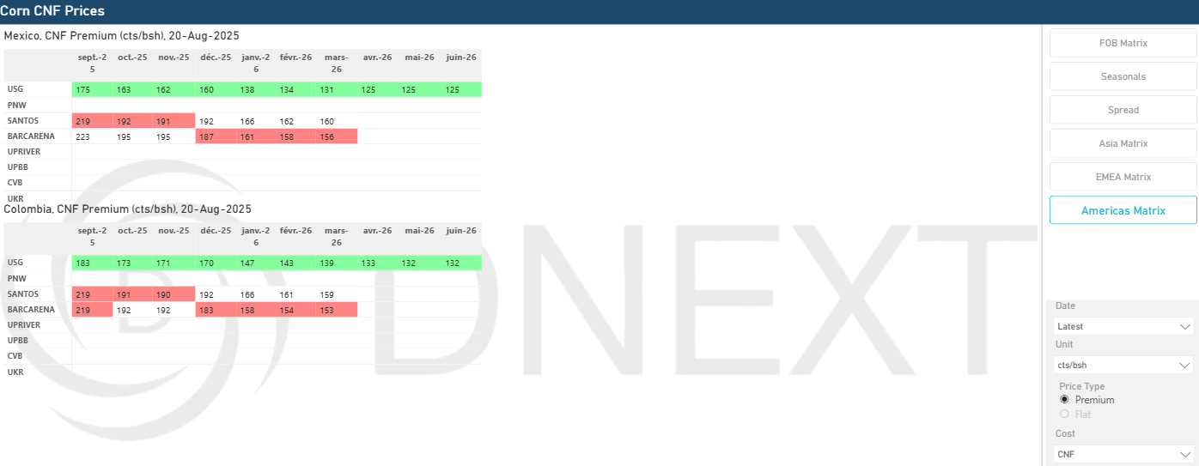

**Example 2 : Wheat Cash Prices**

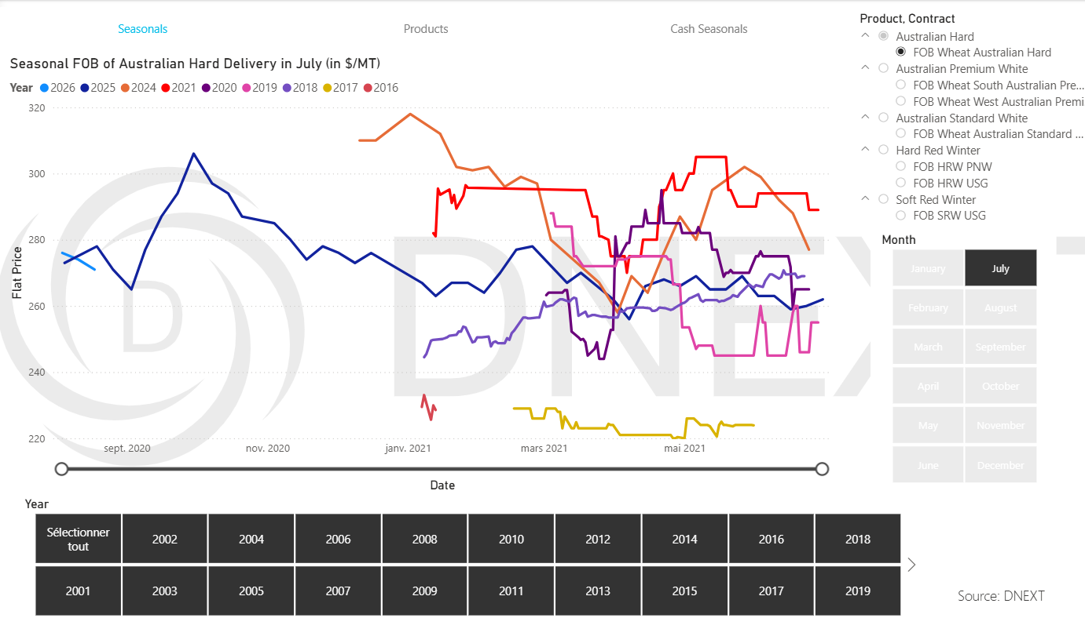

**Example 3 : Brazil Prices**

**Summary :**

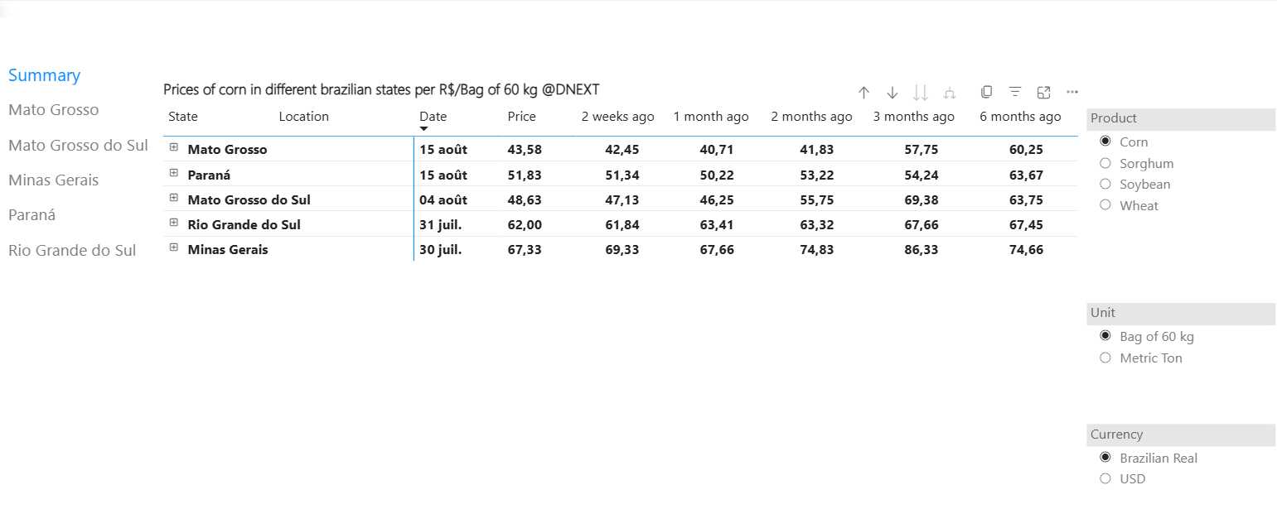

* Main Metrics / KPIs :
* Corn price (2 weeks ago, 1 month ago, 2 months ago, 3 months ago, 6 months ago…).
* Filters / Parameters:
* Product Selection: Soybean or Wheat or Corn or Sorghum
* Unit : Bag of 60 kg or Metric Ton
* Currency : Brazilian Real or USD
* Brazil states selection : Mato Grosso, Mato Grosso do Sul, Paraná, Minas Gerais, Rio Grande do Sul

**Mato Grosso :**

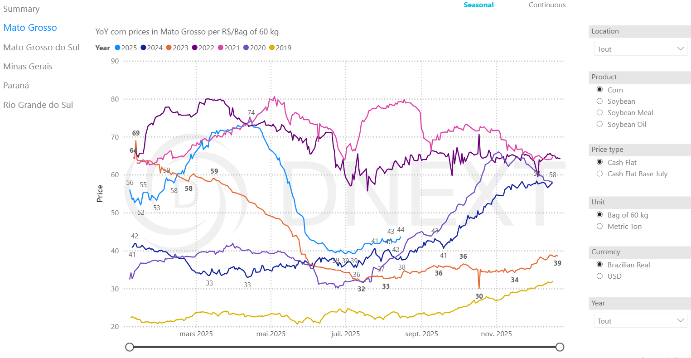

* Main Metrics / KPIs :
* YoY [Product] prices in [Brazilian State] per [Unit].
* Filters / Parameters:
* Location Selection
* Product Selection: Soybean or Soybean Oil or Wheat or Corn or Barley
* Price type : Cash Flat or Cash Flat Base July
* Unit Selection : Bag of 60 kg or Metric Ton
* Currency Selection : Brazilian Real or USD
* Year Selection

# **Grain Processing for Compound Feed**

* Purpose :

To monitor and analyze the annual and monthly quantities of grains processed into compound feed in Europe (France, Germany, Spain, UK,…), segmented by grain and product type over selected crop years.

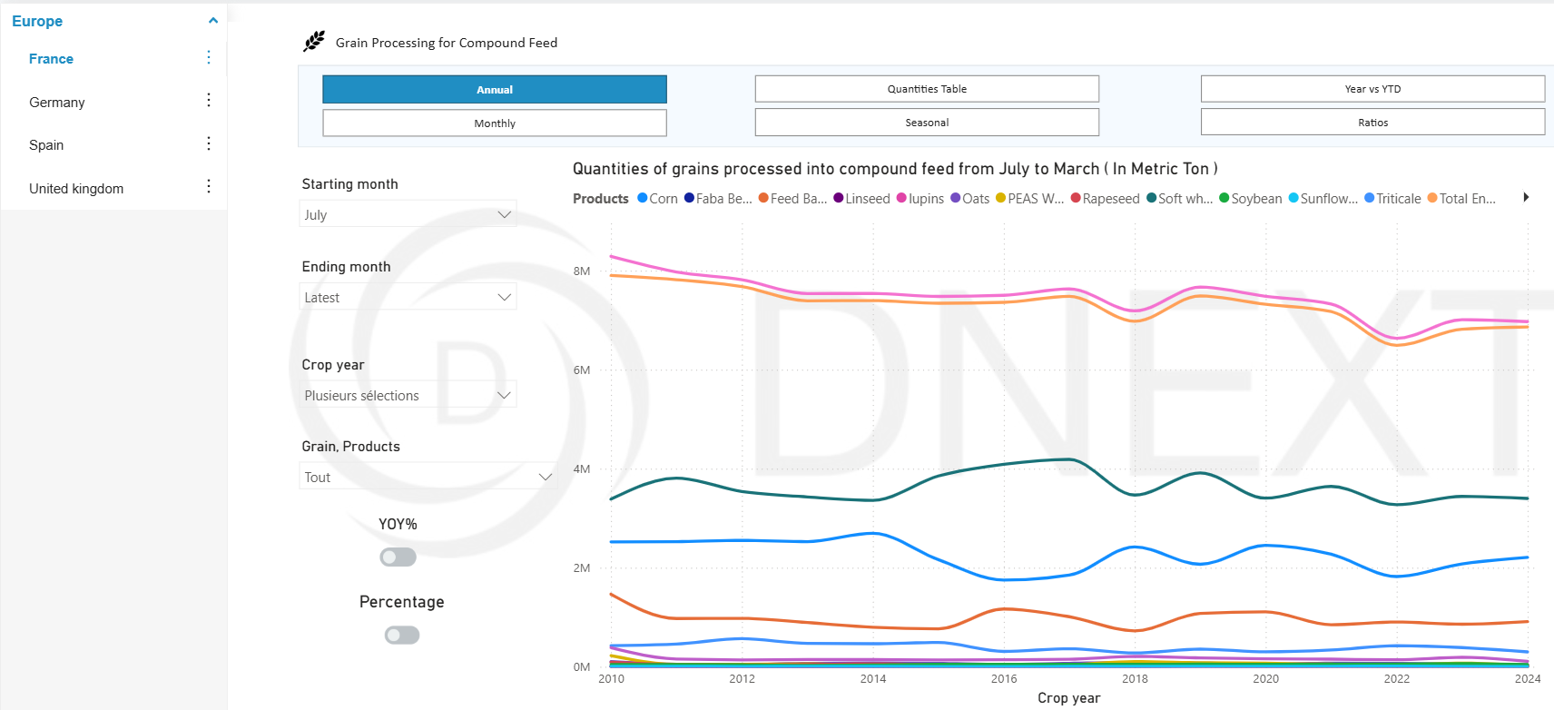

* Main Metrics / KPIs :
* Quantities of grains processed into compound feed (in metric tons)
* Filters / Parameters :
* Geography: Country selection (France, United Kingdom,...)
* Period: Starting month, Ending month
* Crop Year: Multiple selections possible
* Grains / Products
* View Mode: Annual or Monthly
* Analysis Type: Quantities table, Seasonal, Year vs YTD, Ratios

**Quantities Table View:** Displays volumes of grains (e.g., corn, wheat, soybeans, rapeseed) processed into compound feed for the selected period, segmented by product type. It includes year-over-year (YoY%) comparisons. Values are expressed in metric tons, thousand metric tons, or million metric tons depending on the unit selected.

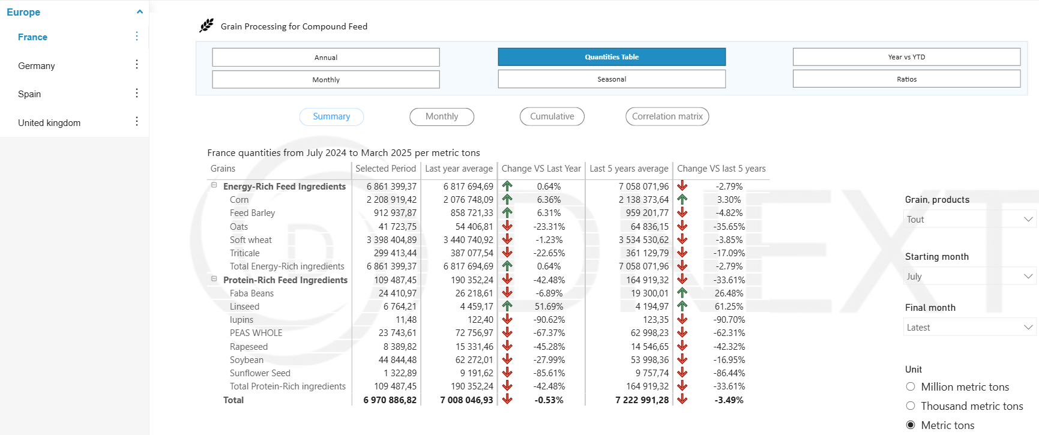

# **Lineups**

* Purpose :

This dashboard provides a comprehensive overview of agricultural exports/imports (grains, oilseeds, fertilizers,...) to key global markets. It tracks trade volumes and compares current performance against historical data.

**Example : France Lineups :**

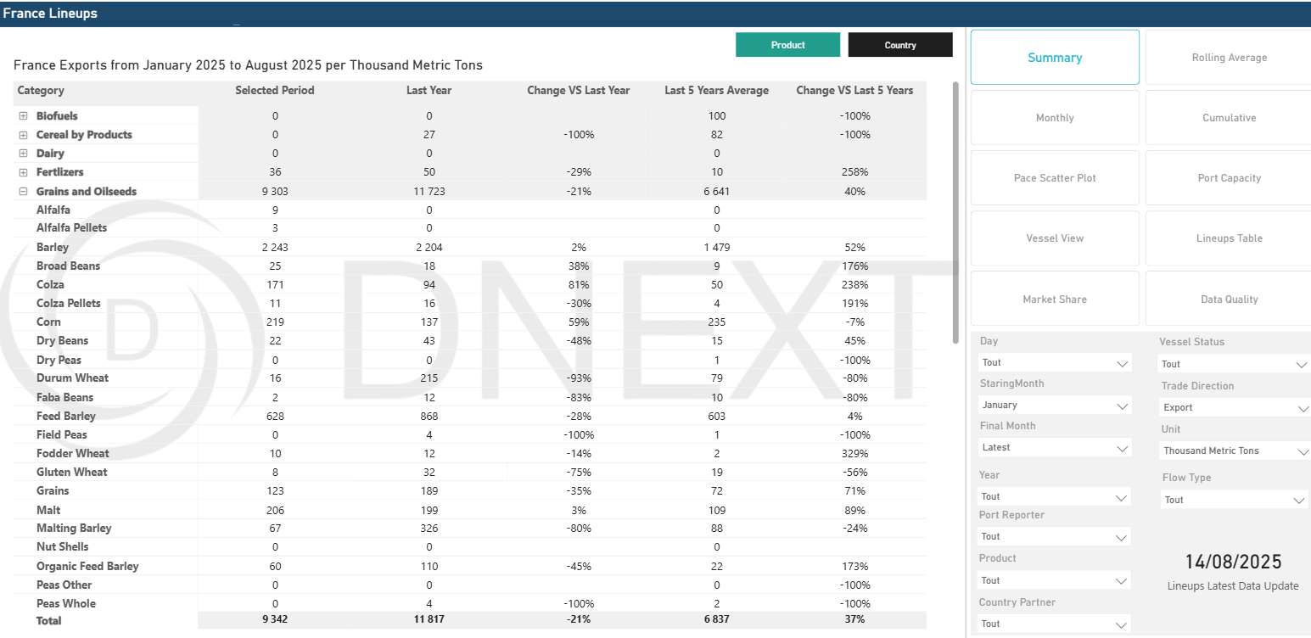

* Main Metrics / KPIs :
* Last Year Average
* Change vs Last Year
* Last 5 Years Average
* Change vs Last 5 Years
* Total Imports / Exports
* Filters / Parameters:
* Summary / Monthly / Cumulative / Rolling Average / Pace Scatter Plot / Port Capacity / Vessel View / Lineups Table / Market Share / Data Quality : Switch between different views of the data.
* Day Selection
* Starting Month : Select the first month for the reporting period (e.g., January, February).
* Year Selection
* Unit : Measurement unit (here it’s thousand metric tons).
* Country Partner
* Trade Direction : Import or Export.
* Port Reporter
* Final Month : Select the last month for the reporting period (e.g., June, July, Latest).
* Category and Product Name : Filter by product group (e.g., Dairy, Fertilizers, Grains and Oilseeds) or specific commodities (e.g., Corn, Rice, Soybean).
* Vessel Status
* Flow Type : Extra-flow / Intra-flow

# **Meat Production**

* Purpose :

To monitor and analyze the annual and monthly production quantities of meat in a specific country segmented by product type over selected crop years.

**Example : Livestock and Meat Production :**

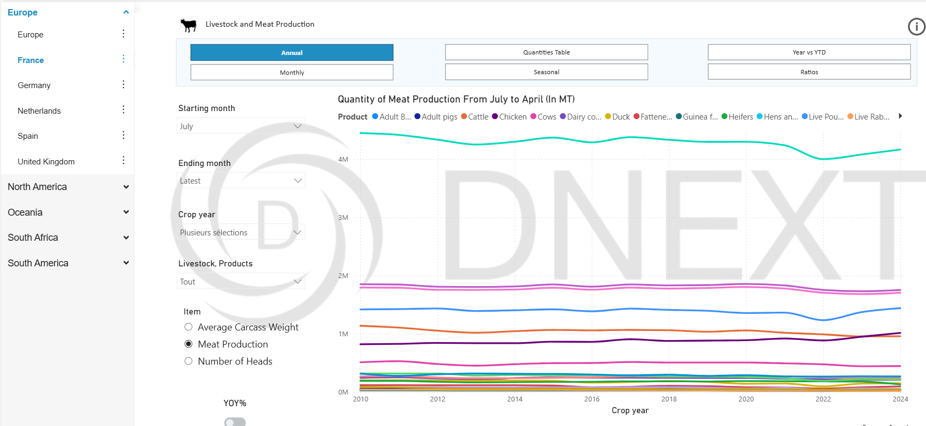

* Main Metrics / KPIs :
* Meat Production Quantity in a Specific Period
* Filters / Parameters :
* Country selection : (France, United Kingdom,...)
* Period: Starting month, Ending month
* Crop Year: Multiple selections possible
* Livestock, Products
* View Mode: Annual or Monthly
* Analysis Type: Quantities table, Seasonal, Year vs YTD, Ratios

# **Sugar Production**

* Purpose :

Track and analyze sugar production statistics across different regions of a country, presenting historical data in metric tons. It enables comparison of production trends by region and year, highlighting total output and regional contributions to a country's sugar industry.

**Example : Argentina Sugar Statistics**

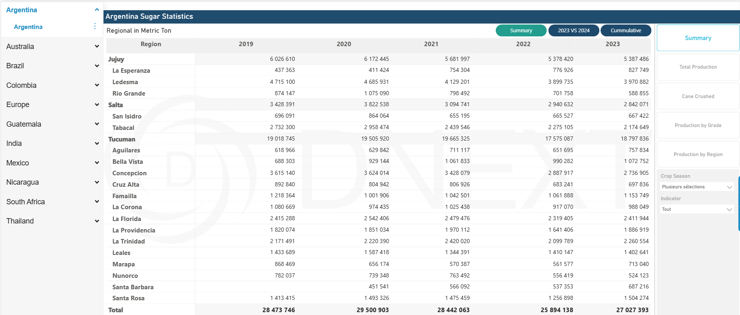

* Main Metrics / KPIs :
* [A country’s] sugar production statistics in metric ton.
* Filters / Parameters :
* Country selection : Argentina, Brazil, Thailand…
* Time-Based Parameters
* Analysis Type: Summary, Total Production, Cane crushed, Production by Grade, Production by Region

# **Supply and Demand**

**Example : USA supply and demand**

**Baseline / Outlook :**

* Purpose :

Its primary objective is to perform comparative analysis and forecasting of USA agricultural market by examining historical data (the baseline) against future projections.

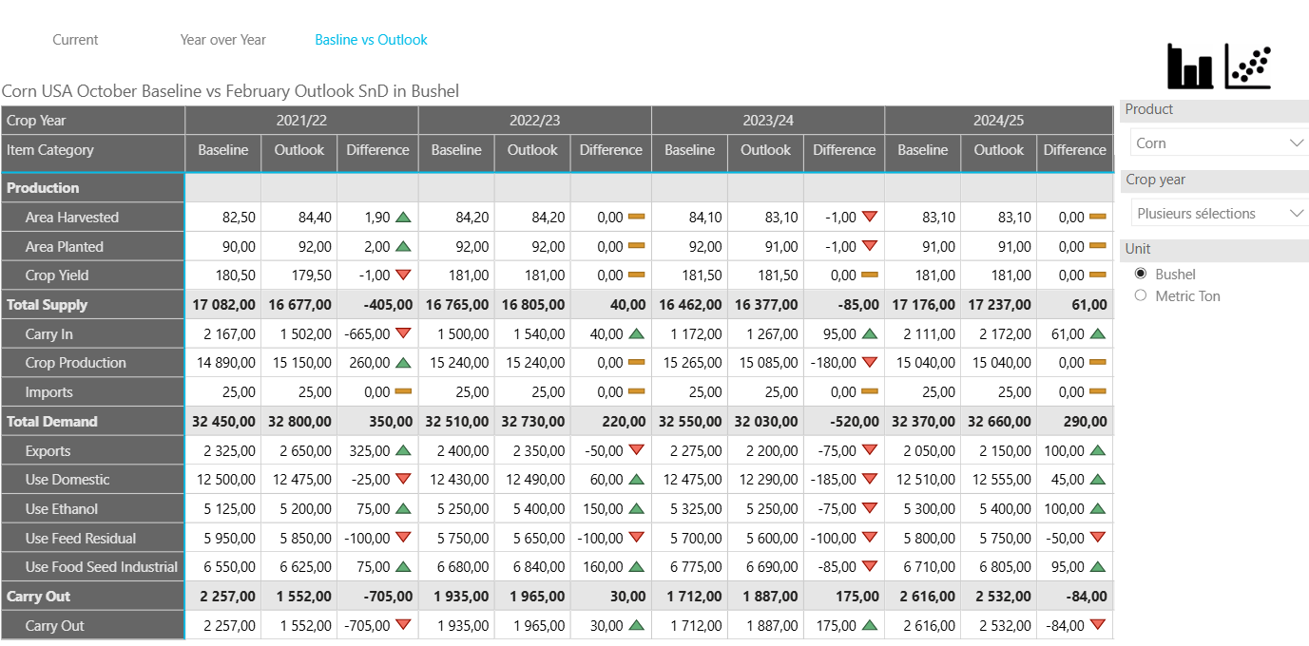

**Biofuels Production :**

* Purpose :

To analyse USA Biofuel production capacity in Thousand M3 per year.

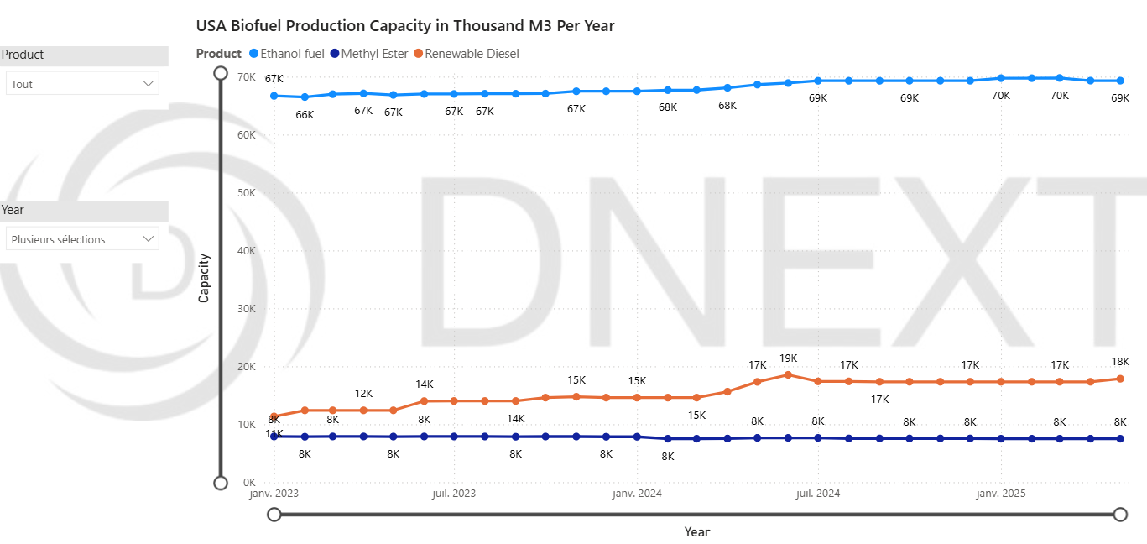

* Main Metrics / KPIs :
* [A country’s] biofuel production capacity in Thousand M3 per year. (In this Example, it is USA).
* Filters / Parameters :
* Product selection : Renewable Diesel / Methyl Ester / Ethanol fuel
* Year selection

**Biofuels SND :**

* Purpose :

Shows the core components (Consumption,Production, Net Imports) of the market's flow over time and the stock level of biofuels held in storage tanks across the country.

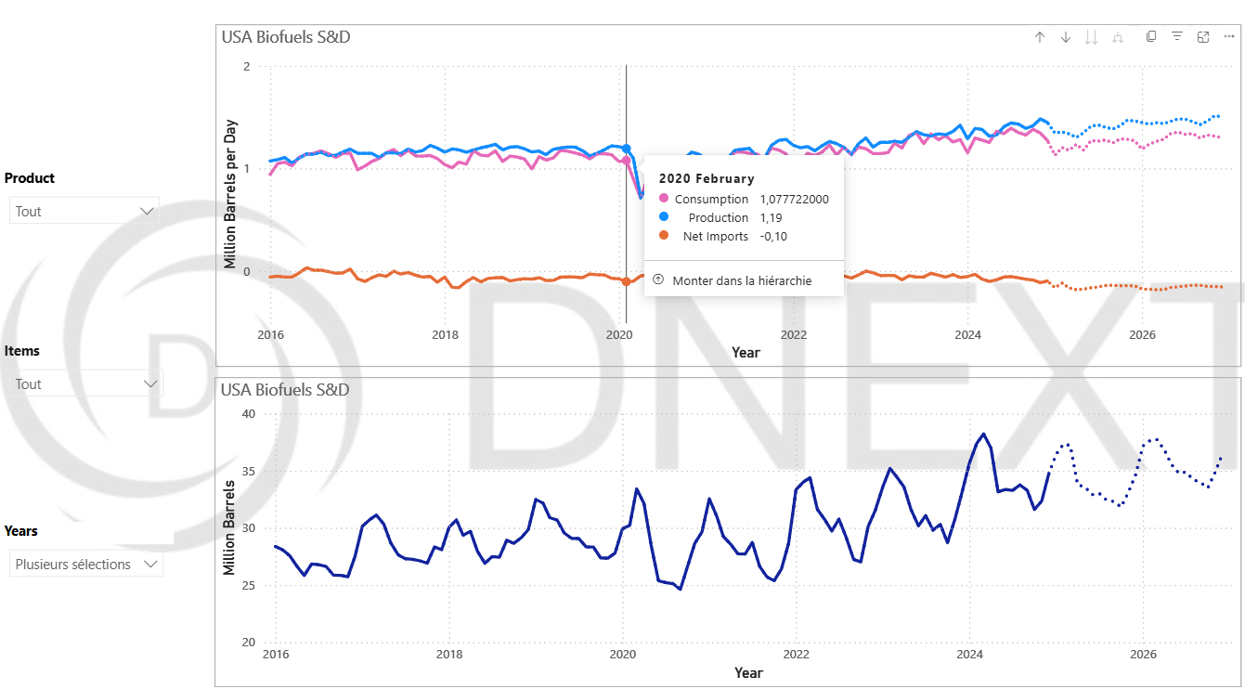

* Main Metrics / KPIs :
* Core components (Consumption,Production, Net Imports) of market’s flow over time.
* The stock level of biofuels held in storage tanks across the country.
* Filters / Parameters :
* Product selection : Ethanol / Fame 0 / Other Biofuel / Renewable Diesel
* Items selection : Consumption / Inventory / Net Imports / Production
* Years selection

**Export Sales :**

* Purpose :

Track and analyze international sales and commitments of USA agricultural products across different countries and years.

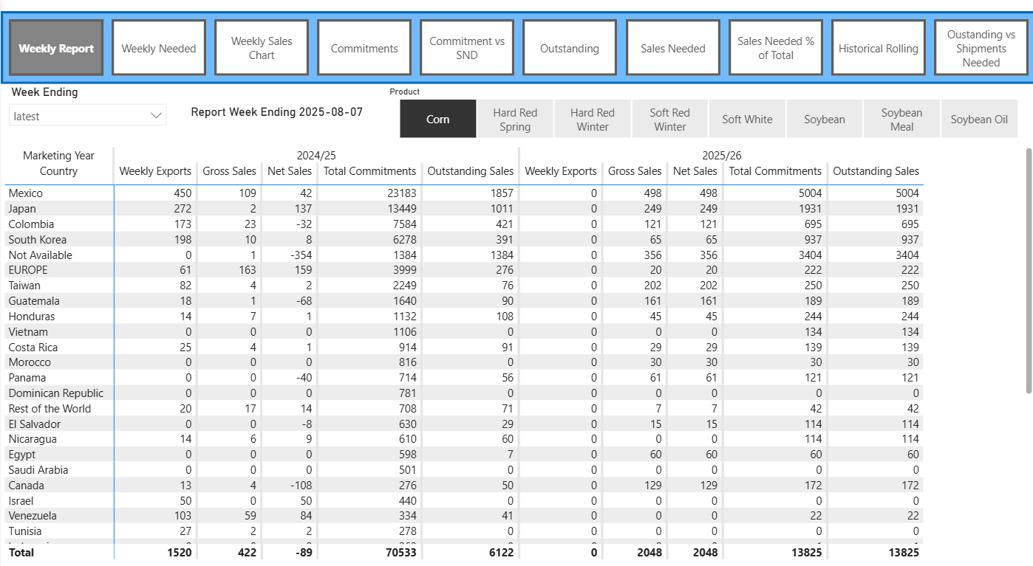

**Feedstock consumed for production of Biofuels :**

* Purpose :

Shows feedstock consumed for production of a specific Biofuel.

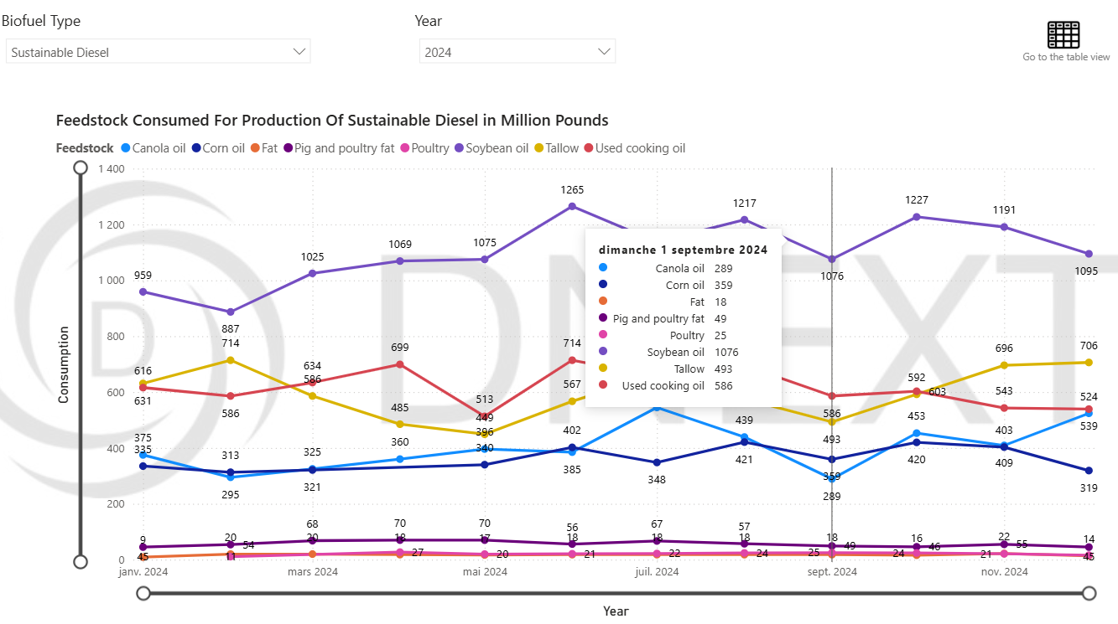

* Main Metrics / KPIs :
* Feedstock consumed for production of [Biofuel Type] in [Year]
* Filters / Parameters :
* Biofuel type selection : Ethanol Fuel / Sustainable Diesel / Other Biofuel
* Year selection

# **11. Weather**

**Example : USA Weather**

**Dashboard 1 : Temperature Visualization**

* Purpose :

To show temperature in USA regions.

**Forecast :**

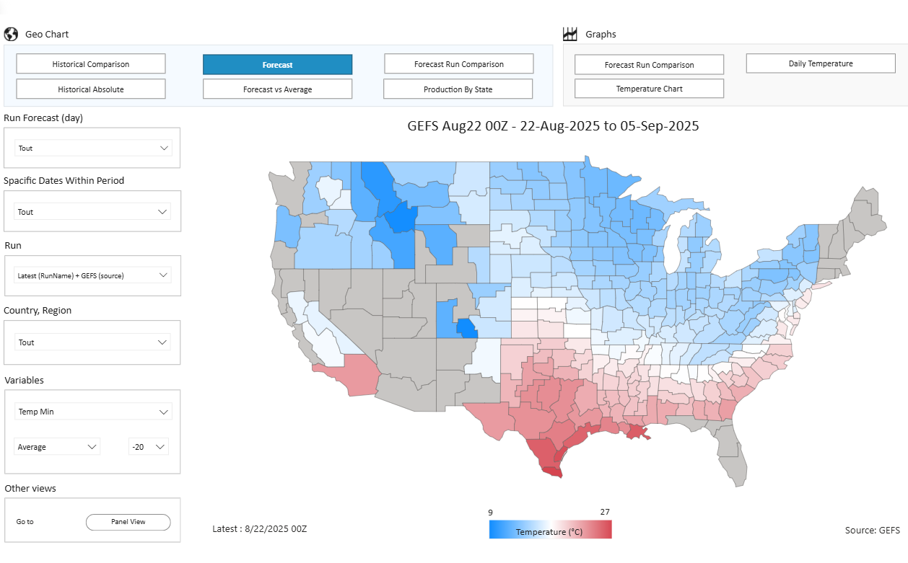

**Daily Temperature :**

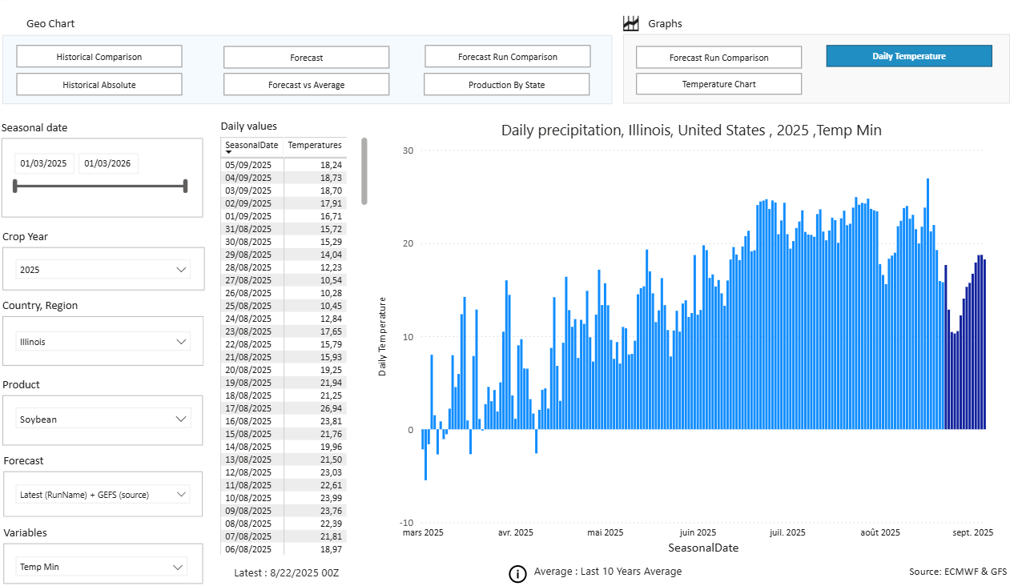

**Dashboard 2 : Precipitation Visualization**

* Purpose :

To show precipitation in USA regions.

**Forecast :**

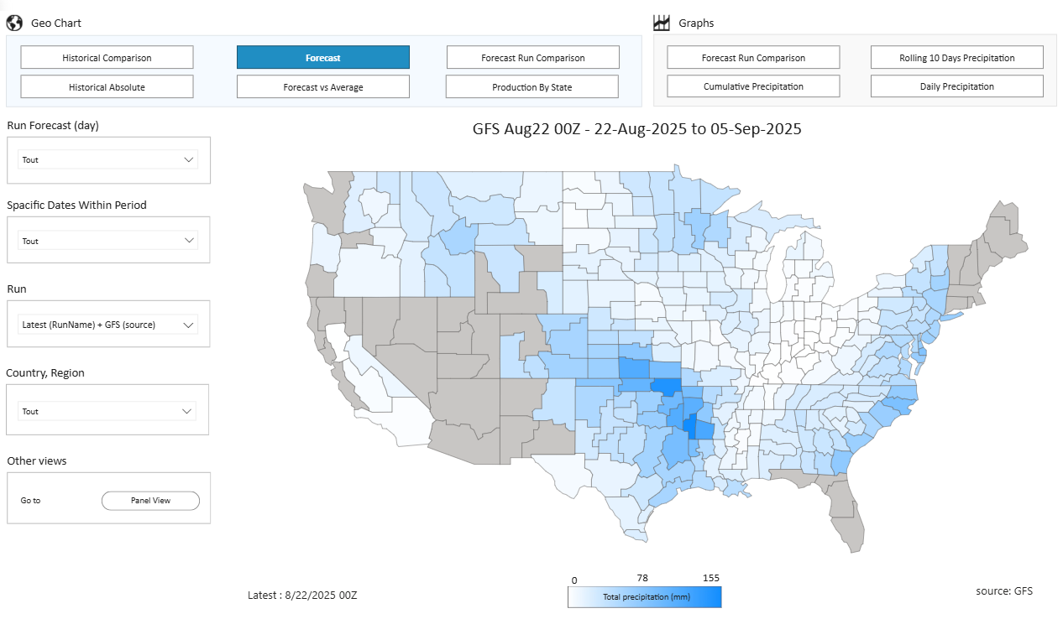

**Daily Precipitation :**

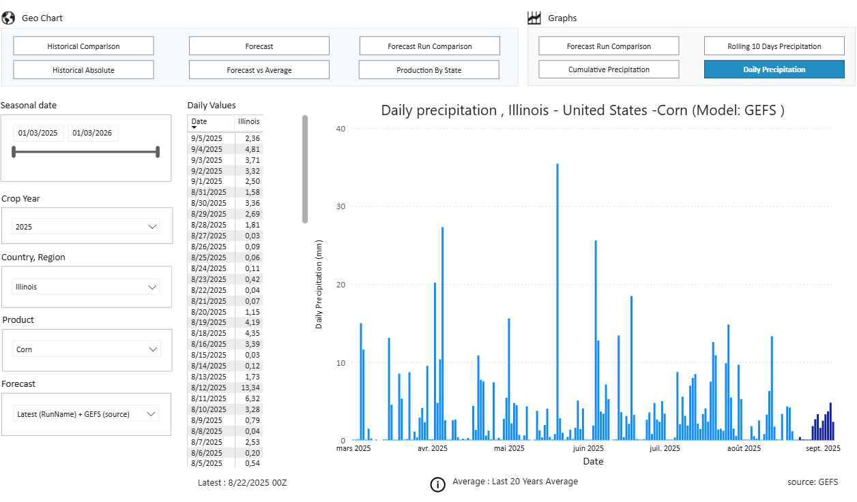

**Dashboard 3 : Soil Moisture and NDVI (Country level)**

**Soil Moisture ( Country Level ) :**

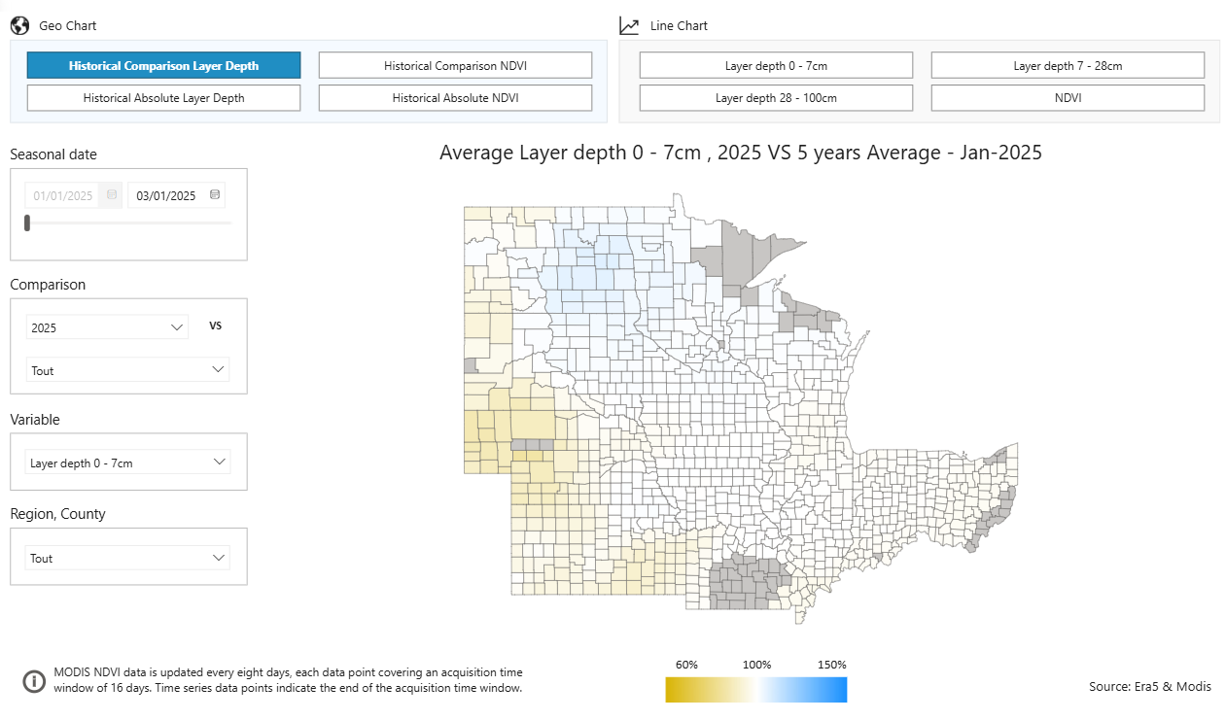

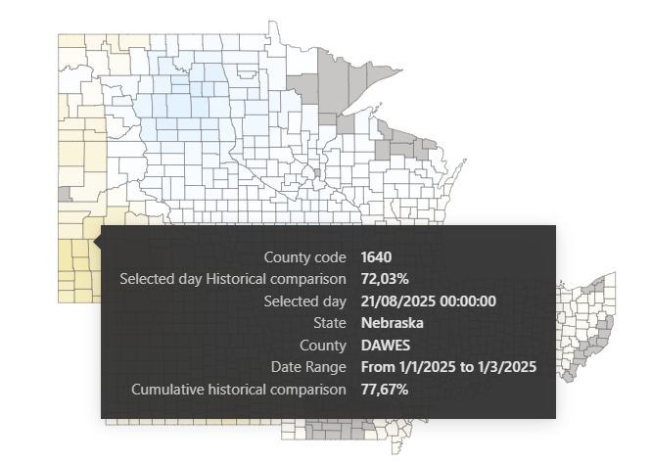

The soil moisture in the top layer (0-7cm) was only 72.03% of the 5-year average for that same day.

It is significantly drier than normal and it has less than three-quarters of the moisture it typically would have at that time of the year.

The soil moisture is at 77.67% of the expected level for this time of the year.

**NDVI ( Country Level ) :**

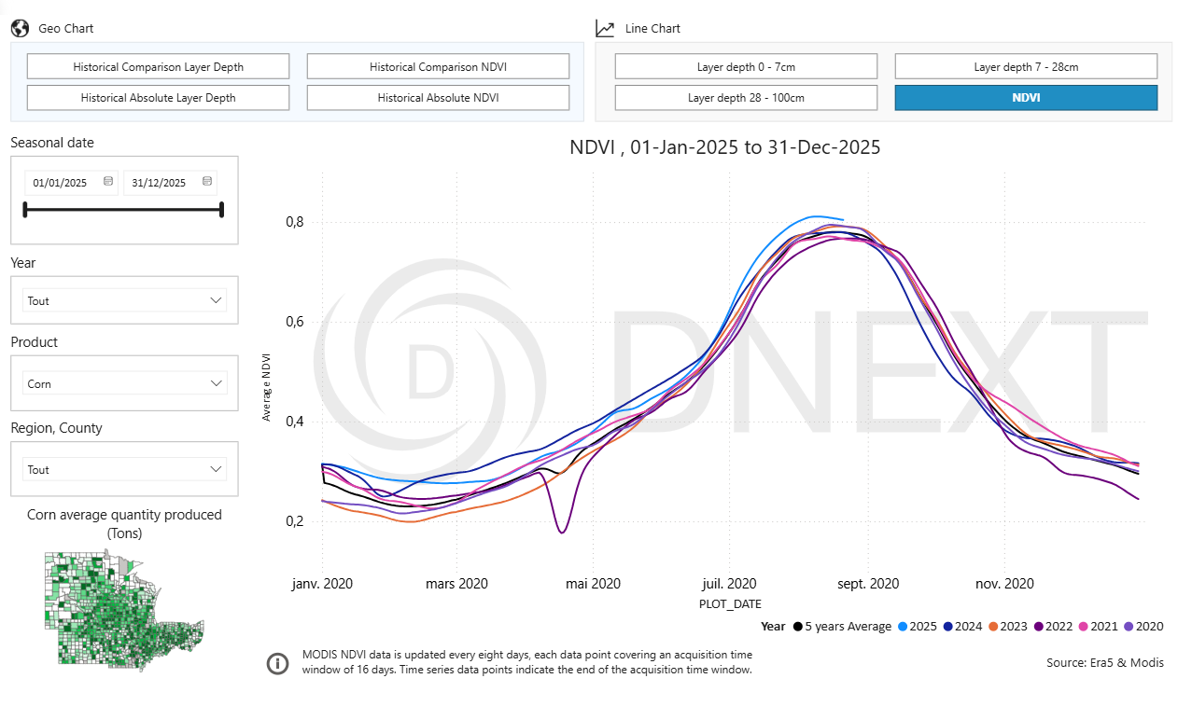

**Dashboard 4 : Soil Moisture and NDVI (State level)**

**Soil Moisture : ( State level )**

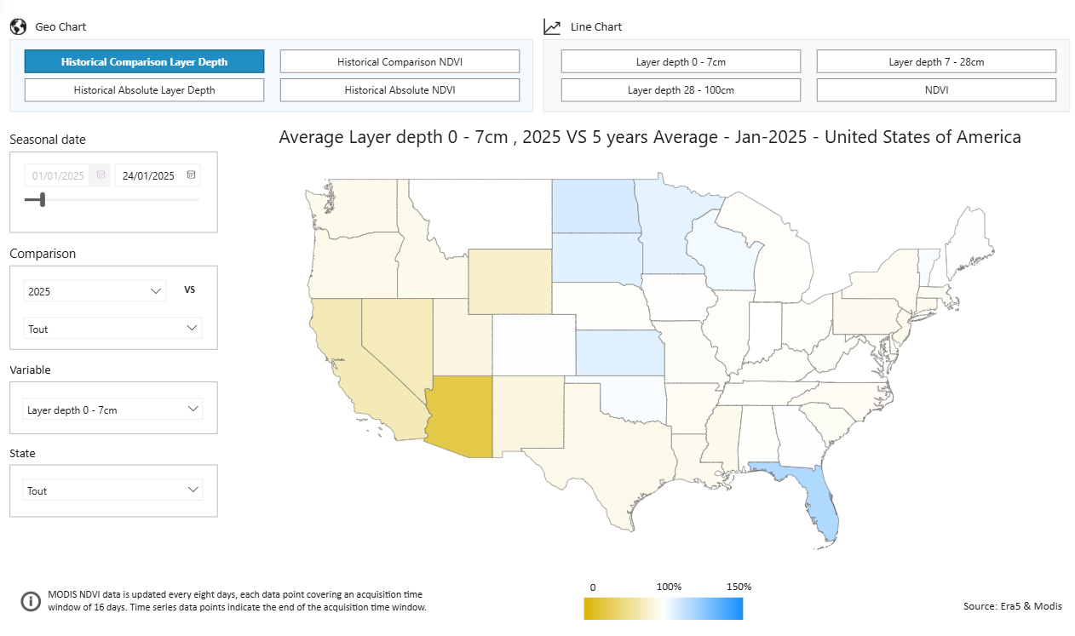

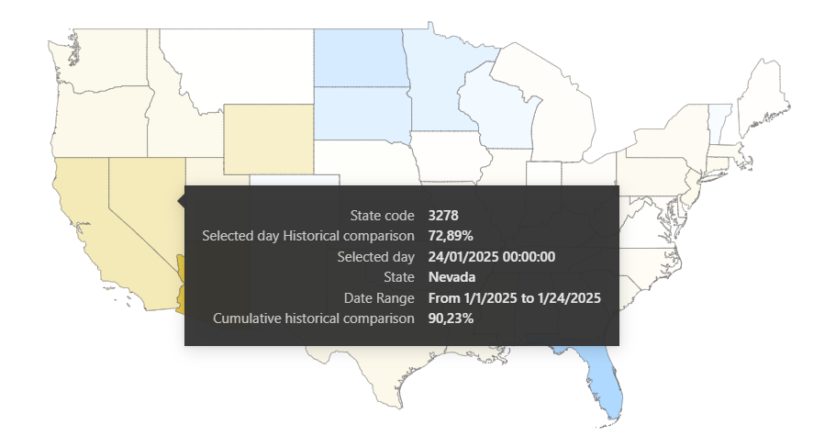

72,89%: The soil moisture on January 24, 2025, was at 72.89% of the normal level for that specific day. This means the soil was significantly drier than average on that date.

90,23% : The average soil moisture for the entire period from January 1 to January 24, 2025, was at 90.23% of normal. This means the whole month was dry, but not as severely dry as it was on the specific date of Jan 24.

**NDVI ( State Level ) :**

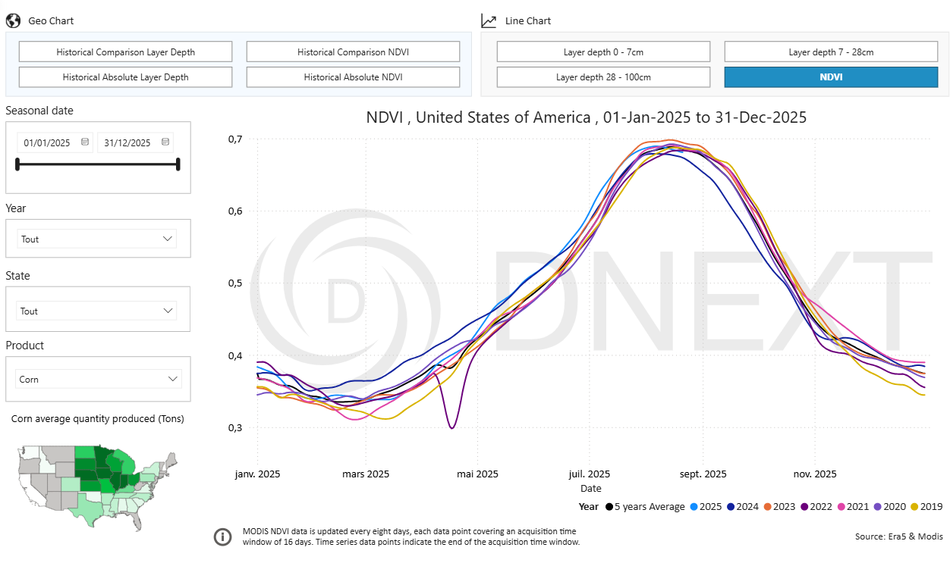

**Dashboard 5 : Station Data**

**Example : Climate Metric = Precipitation**

* Purpose :

The purpose of this dashboard is to provide a quick and clear view of recent rainfall using data from the U.S. National Weather Service (NWS).

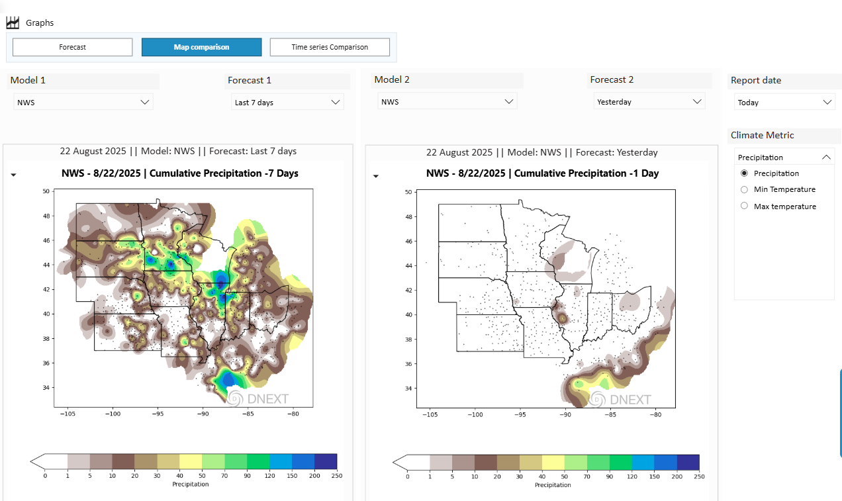

# **12. Freight Matrix**

* Purpose :

Its primary purpose is to provide a quick, at-a-glance comparison of freight costs for moving different types of commodities on various shipping routes, using different vessel sizes.

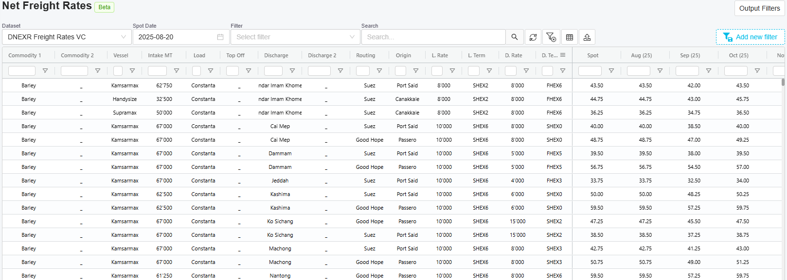

# **13. Geographic Scope of DNEXT Analysis**

